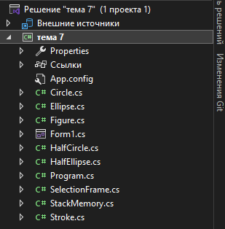
Структура
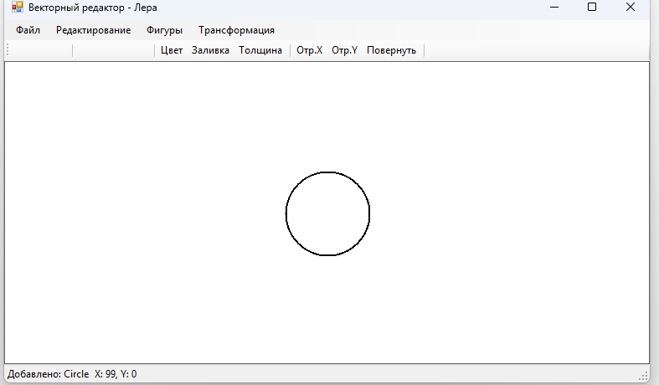
Круг
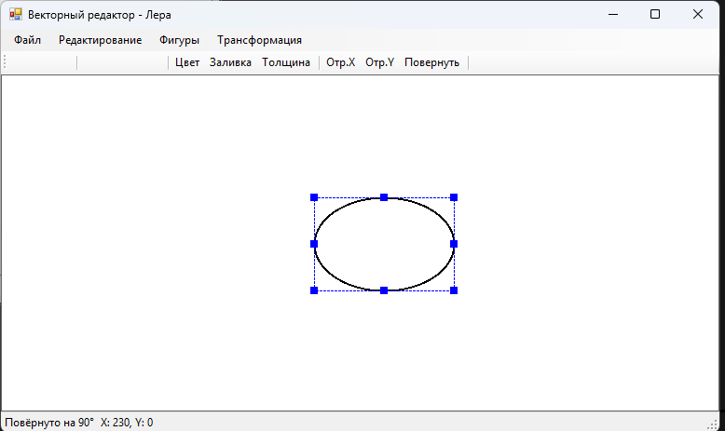
Эллипс
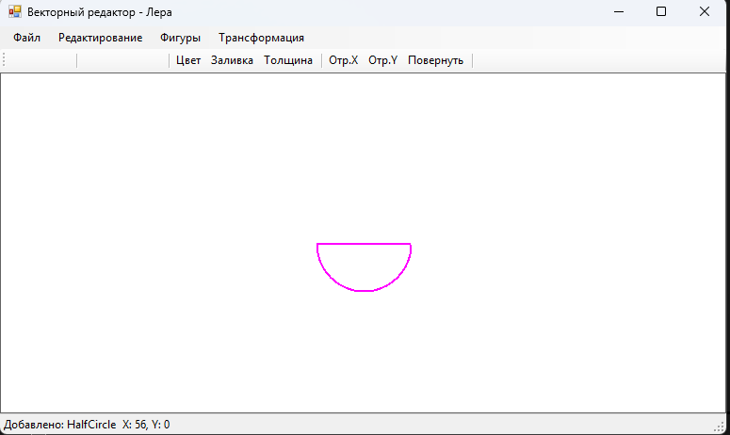
Половина круга
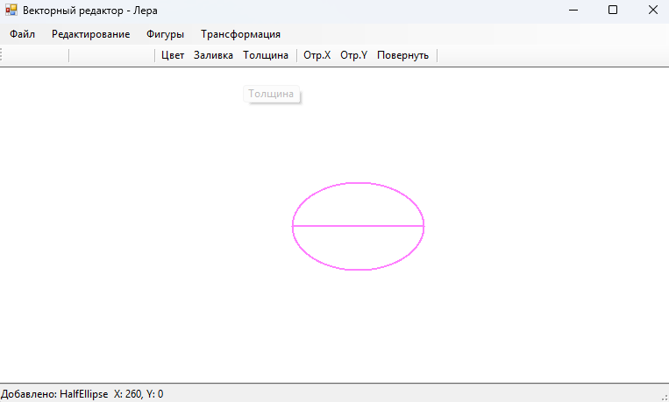
Половина эллипса

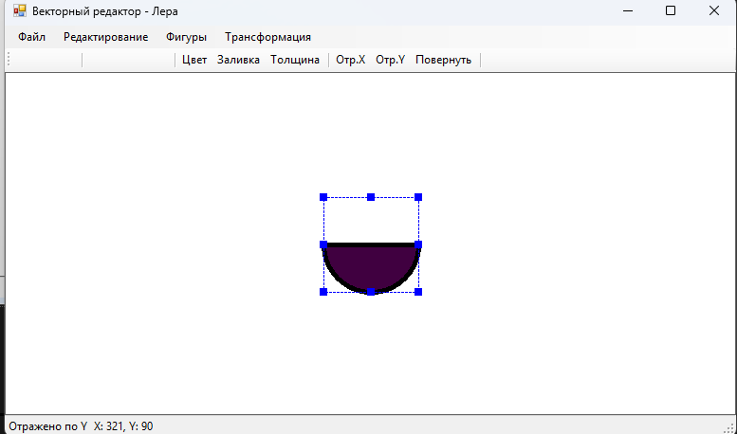
Изменение цвета заливки и т.д
Код Circle.cs:
using System;
using System.Drawing;

namespace тема_7
{
[Serializable]
public class Circle : Figure
{
public Circle(Point location, Size size, Stroke stroke) : base(location, size, stroke) { }

public override void Draw(Graphics g)
{
int diameter = Math.Min(Size.Width, Size.Height);
var rect = new Rectangle(Location.X, Location.Y, diameter, diameter);

if (Stroke.HasFill && Stroke.FillColor != Color.Transparent)
{
using (var brush = new SolidBrush(Stroke.FillColor))
g.FillEllipse(brush, rect);
}

using (var pen = Stroke.GetPen())
g.DrawEllipse(pen, rect);
}

public override bool ContainsPoint(Point point)
{
int radius = Math.Min(Size.Width, Size.Height) / 2;
Point center = new Point(Location.X + radius, Location.Y + radius);
int dx = point.X - center.X;
int dy = point.Y - center.Y;
return dx * dx + dy * dy <= radius * radius;
}
}
}
Код Ellipse.cs:
using System;
using System.Drawing;

namespace тема_7
{
[Serializable]
public class Ellipse : Figure
{
public Ellipse(Point location, Size size, Stroke stroke) : base(location, size, stroke) { }

public override void Draw(Graphics g)
{
var rect = new Rectangle(Location.X, Location.Y, Size.Width, Size.Height);

if (Stroke.HasFill && Stroke.FillColor != Color.Transparent)
{
using (var brush = new SolidBrush(Stroke.FillColor))
g.FillEllipse(brush, rect);
}

using (var pen = Stroke.GetPen())
g.DrawEllipse(pen, rect);
}

public override bool ContainsPoint(Point point)
{
Point center = new Point(Location.X + Size.Width / 2, Location.Y + Size.Height / 2);
double rx = Size.Width / 2.0;
double ry = Size.Height / 2.0;
if (rx == 0 || ry == 0) return false;
double dx = (point.X - center.X) / rx;
double dy = (point.Y - center.Y) / ry;
return dx * dx + dy * dy <= 1;
}
}
}
Код Figure.cs:
using System;
using System.Drawing;

namespace тема_7
{
[Serializable]
public abstract class Figure
{
public Point Location { get; set; }
public Size Size { get; set; }
public Stroke Stroke { get; set; }
public int Id { get; set; }
protected bool _reflectedX;
protected bool _reflectedY;
protected float _rotationAngle;

protected Figure(Point location, Size size, Stroke stroke)
{
Location = location;
Size = size;
Stroke = stroke?.Clone() ?? new Stroke();
Id = GetHashCode();
}

public Rectangle Bounds => new Rectangle(Location, Size);

public abstract void Draw(Graphics g);

public virtual void Move(int dx, int dy)
{
Location = new Point(Location.X + dx, Location.Y + dy);
}

public void ShiftRight(int pixels) => Move(pixels, 0);
public void ShiftLeft(int pixels) => Move(-pixels, 0);
public void ShiftUp(int pixels) => Move(0, -pixels);
public void ShiftDown(int pixels) => Move(0, pixels);

public virtual bool ContainsPoint(Point point)
{
return Bounds.Contains(point);
}

public virtual void ReflectX() => _reflectedX = !_reflectedX;
public virtual void ReflectY() => _reflectedY = !_reflectedY;
public virtual void Rotate(float angle) => _rotationAngle = (_rotationAngle + angle) % 360;

public virtual Figure Clone()
{
var fig = (Figure)MemberwiseClone();
fig.Stroke = Stroke.Clone();
return fig;
}

public virtual void Resize(int newWidth, int newHeight)
{
Size = new Size(Math.Max(10, newWidth), Math.Max(10, newHeight));
}
}
}
Код Form1.cs:
using System;
using System.Collections.Generic;
using System.Drawing;
using System.IO;
using System.Runtime.Serialization;
using System.Runtime.Serialization.Formatters.Binary;
using System.Windows.Forms;

namespace тема_7
{
public partial class Form1 : Form
{
private List<Figure> _figures = new List<Figure>();
private List<Figure> _clipboard = new List<Figure>();
private Figure _selectedFigure;
private SelectionFrame _selectionFrame = new SelectionFrame();
private StackMemory _undoStack = new StackMemory(20);
private StackMemory _redoStack = new StackMemory(20);
private Color _currentColor = Color.Black;
private Color _currentFillColor = Color.Transparent;
private bool _hasFill = false;
private float _currentStrokeWidth = 2f;
private Point _startPoint;

public Form1()
{
InitializeComponent();
DoubleBuffered = true;
}

private void SaveState()
{
_undoStack.Push(ObjectToStream(_figures));
_redoStack.Clear();
}

private MemoryStream ObjectToStream(List<Figure> figures)
{
var ms = new MemoryStream();
new BinaryFormatter().Serialize(ms, figures);
ms.Position = 0;
return ms;
}

private List<Figure> StreamToObject(MemoryStream ms)
{
ms.Position = 0;
return (List<Figure>)new BinaryFormatter().Deserialize(ms);
}

private void PanelCanvas_Paint(object sender, PaintEventArgs e)
{
Graphics g = e.Graphics;
g.Clear(Color.White);

foreach (var figure in _figures)
figure.Draw(g);

if (_selectedFigure != null)
{
_selectionFrame.Update(_selectedFigure);
_selectionFrame.Draw(g);
}
}

private void PanelCanvas_MouseDown(object sender, MouseEventArgs e)
{
_startPoint = e.Location;
Figure clicked = FindFigureAt(e.Location);
if (clicked != null)
{
if (_selectedFigure != clicked)
{
SaveState();
_selectedFigure = clicked;
}
}
else
{
_selectedFigure = null;
}
panelCanvas.Invalidate();
}

private Figure FindFigureAt(Point point)
{
for (int i = _figures.Count - 1; i >= 0; i--)
if (_figures[i].ContainsPoint(point))
return _figures[i];
return null;
}

private void CreateFigure(FigureType type)
{
var stroke = new Stroke(_currentColor, _currentStrokeWidth)
{
FillColor = _currentFillColor,
HasFill = _hasFill
};

Figure figure;
Point loc = new Point(panelCanvas.Width / 2 - 50, panelCanvas.Height / 2 - 50);

switch (type)
{
case FigureType.Circle:
figure = new Circle(loc, new Size(100, 100), stroke);
break;
case FigureType.Ellipse:
figure = new Ellipse(loc, new Size(150, 100), stroke);
break;
case FigureType.HalfCircle:
figure = new HalfCircle(loc, new Size(100, 100), stroke);
break;
case FigureType.HalfEllipse:
figure = new HalfEllipse(loc, new Size(150, 100), stroke);
break;
default:
figure = new Circle(loc, new Size(100, 100), stroke);
break;
}

SaveState();
_figures.Add(figure);
_selectedFigure = figure;
panelCanvas.Invalidate();
lblStatus.Text = "Добавлено: " + figure.GetType().Name;
}

private enum FigureType { Circle, Ellipse, HalfCircle, HalfEllipse }

private void MainForm_KeyDown(object sender, KeyEventArgs e)
{
if (_selectedFigure == null) return;
int pixels = e.Shift ? 1 : 5;

SaveState();

switch (e.KeyCode)
{
case Keys.Left: _selectedFigure.ShiftLeft(pixels); break;
case Keys.Right: _selectedFigure.ShiftRight(pixels); break;
case Keys.Up: _selectedFigure.ShiftUp(pixels); break;
case Keys.Down: _selectedFigure.ShiftDown(pixels); break;
case Keys.Delete: DeleteSelected(); return;
default: return;
}
panelCanvas.Invalidate();
}

private void DeleteSelected()
{
if (_selectedFigure != null)
{
SaveState();
_figures.Remove(_selectedFigure);
_selectedFigure = null;
panelCanvas.Invalidate();
lblStatus.Text = "Удалено";
}
}

// ========== Меню Файл ==========
private void NewToolStripMenuItem_Click(object sender, EventArgs e)
{
if (_figures.Count > 0 && MessageBox.Show("Очистить холст?", "Новый", MessageBoxButtons.YesNo) != DialogResult.Yes)
return;
SaveState();
_figures.Clear();
_selectedFigure = null;
panelCanvas.Invalidate();
lblStatus.Text = "Новый холст";
}

private void SaveToolStripMenuItem_Click(object sender, EventArgs e)
{
if (saveFileDialog1.ShowDialog() == DialogResult.OK)
{
try
{
using (var fs = new FileStream(saveFileDialog1.FileName, FileMode.Create))
new BinaryFormatter().Serialize(fs, _figures);
lblStatus.Text = "Сохранено";
}
catch (Exception ex) { MessageBox.Show("Ошибка: " + ex.Message); }
}
}

private void LoadToolStripMenuItem_Click(object sender, EventArgs e)
{
if (openFileDialog1.ShowDialog() == DialogResult.OK)
{
try
{
using (var fs = new FileStream(openFileDialog1.FileName, FileMode.Open))
_figures = (List<Figure>)new BinaryFormatter().Deserialize(fs);
_selectedFigure = null;
panelCanvas.Invalidate();
lblStatus.Text = "Загружено";
}
catch (Exception ex) { MessageBox.Show("Ошибка: " + ex.Message); }
}
}

// ========== Меню Редактирование ==========
private void UndoToolStripMenuItem_Click(object sender, EventArgs e)
{
if (_undoStack.Count > 0)
{
var ms = new MemoryStream();
_undoStack.Pop(ms);
_redoStack.Push(ObjectToStream(_figures));
_figures = StreamToObject(ms);
_selectedFigure = null;
panelCanvas.Invalidate();
lblStatus.Text = "Отменено";
}
}

private void RedoToolStripMenuItem_Click(object sender, EventArgs e)
{
if (_redoStack.Count > 0)
{
var ms = new MemoryStream();
_redoStack.Pop(ms);
_undoStack.Push(ObjectToStream(_figures));
_figures = StreamToObject(ms);
_selectedFigure = null;
panelCanvas.Invalidate();
lblStatus.Text = "Возврат";
}
}

private void CopyToolStripMenuItem_Click(object sender, EventArgs e)
{
if (_selectedFigure != null)
{
_clipboard.Clear();
_clipboard.Add(_selectedFigure.Clone());
lblStatus.Text = "Скопировано";
}
}

private void CutToolStripMenuItem_Click(object sender, EventArgs e)
{
if (_selectedFigure != null)
{
_clipboard.Clear();
_clipboard.Add(_selectedFigure.Clone());
SaveState();
_figures.Remove(_selectedFigure);
_selectedFigure = null;
panelCanvas.Invalidate();
lblStatus.Text = "Вырезано";
}
}

private void PasteToolStripMenuItem_Click(object sender, EventArgs e)
{
if (_clipboard.Count > 0)
{
SaveState();
var pasted = _clipboard[0].Clone();
pasted.Location = new Point(pasted.Location.X + 20, pasted.Location.Y + 20);
_figures.Add(pasted);
_selectedFigure = pasted;
panelCanvas.Invalidate();
lblStatus.Text = "Вставлено";
}
}

private void DeleteToolStripMenuItem_Click(object sender, EventArgs e) => DeleteSelected();

// ========== Меню Фигуры ==========
private void CircleToolStripMenuItem_Click(object sender, EventArgs e) => CreateFigure(FigureType.Circle);
private void EllipseToolStripMenuItem_Click(object sender, EventArgs e) => CreateFigure(FigureType.Ellipse);
private void HalfCircleToolStripMenuItem_Click(object sender, EventArgs e) => CreateFigure(FigureType.HalfCircle);
private void HalfEllipseToolStripMenuItem_Click(object sender, EventArgs e) => CreateFigure(FigureType.HalfEllipse);

// ========== Меню Трансформация ==========
private void ReflectXToolStripMenuItem_Click(object sender, EventArgs e)
{
if (_selectedFigure != null)
{
SaveState();
_selectedFigure.ReflectX();
panelCanvas.Invalidate();
lblStatus.Text = "Отражено по X";
}
}

private void ReflectYToolStripMenuItem_Click(object sender, EventArgs e)
{
if (_selectedFigure != null)
{
SaveState();
_selectedFigure.ReflectY();
panelCanvas.Invalidate();
lblStatus.Text = "Отражено по Y";
}
}

private void Rotate90ToolStripMenuItem_Click(object sender, EventArgs e)
{
if (_selectedFigure != null)
{
SaveState();
_selectedFigure.Rotate(90);
panelCanvas.Invalidate();
lblStatus.Text = "Повёрнуто на 90°";
}
}

// ========== Панель инструментов ==========
private void BtnColor_Click(object sender, EventArgs e)
{
if (colorDialog1.ShowDialog() == DialogResult.OK)
{
_currentColor = colorDialog1.Color;
if (_selectedFigure != null)
{
SaveState();
_selectedFigure.Stroke.Color = _currentColor;
panelCanvas.Invalidate();
}
}
}
Код Form1.designer.cs:
namespace тема_7
{
partial class Form1
{
private System.ComponentModel.IContainer components = null;

protected override void Dispose(bool disposing)
{
if (disposing && (components != null))
components.Dispose();
base.Dispose(disposing);
}

private void InitializeComponent()
{
this.menuStrip = new System.Windows.Forms.MenuStrip();
this.fileToolStripMenuItem = new System.Windows.Forms.ToolStripMenuItem();
this.newToolStripMenuItem = new System.Windows.Forms.ToolStripMenuItem();
this.saveToolStripMenuItem = new System.Windows.Forms.ToolStripMenuItem();
this.loadToolStripMenuItem = new System.Windows.Forms.ToolStripMenuItem();
this.exitToolStripMenuItem = new System.Windows.Forms.ToolStripMenuItem();
this.editToolStripMenuItem = new System.Windows.Forms.ToolStripMenuItem();
this.undoToolStripMenuItem = new System.Windows.Forms.ToolStripMenuItem();
this.redoToolStripMenuItem = new System.Windows.Forms.ToolStripMenuItem();
this.copyToolStripMenuItem = new System.Windows.Forms.ToolStripMenuItem();
this.cutToolStripMenuItem = new System.Windows.Forms.ToolStripMenuItem();
this.pasteToolStripMenuItem = new System.Windows.Forms.ToolStripMenuItem();
this.deleteToolStripMenuItem = new System.Windows.Forms.ToolStripMenuItem();
this.figureToolStripMenuItem = new System.Windows.Forms.ToolStripMenuItem();
this.circleToolStripMenuItem = new System.Windows.Forms.ToolStripMenuItem();
this.ellipseToolStripMenuItem = new System.Windows.Forms.ToolStripMenuItem();
this.halfCircleToolStripMenuItem = new System.Windows.Forms.ToolStripMenuItem();
this.halfEllipseToolStripMenuItem = new System.Windows.Forms.ToolStripMenuItem();
this.transformToolStripMenuItem = new System.Windows.Forms.ToolStripMenuItem();
this.reflectXToolStripMenuItem = new System.Windows.Forms.ToolStripMenuItem();
this.reflectYToolStripMenuItem = new System.Windows.Forms.ToolStripMenuItem();
this.rotate90ToolStripMenuItem = new System.Windows.Forms.ToolStripMenuItem();
this.toolStrip = new System.Windows.Forms.ToolStrip();
this.btnNew = new System.Windows.Forms.ToolStripButton();
this.btnSave = new System.Windows.Forms.ToolStripButton();
this.btnLoad = new System.Windows.Forms.ToolStripButton();
this.toolStripSeparator1 = new System.Windows.Forms.ToolStripSeparator();
this.btnCircle = new System.Windows.Forms.ToolStripButton();
this.btnEllipse = new System.Windows.Forms.ToolStripButton();
this.btnHalfCircle = new System.Windows.Forms.ToolStripButton();
this.btnHalfEllipse = new System.Windows.Forms.ToolStripButton();
this.toolStripSeparator2 = new System.Windows.Forms.ToolStripSeparator();
this.btnColor = new System.Windows.Forms.ToolStripButton();
this.btnFillColor = new System.Windows.Forms.ToolStripButton();
this.btnStrokeWidth = new System.Windows.Forms.ToolStripButton();
this.toolStripSeparator3 = new System.Windows.Forms.ToolStripSeparator();
this.btnReflectX = new System.Windows.Forms.ToolStripButton();
this.btnReflectY = new System.Windows.Forms.ToolStripButton();
this.btnRotate = new System.Windows.Forms.ToolStripButton();
this.toolStripSeparator4 = new System.Windows.Forms.ToolStripSeparator();
this.btnUndo = new System.Windows.Forms.ToolStripButton();
this.btnRedo = new System.Windows.Forms.ToolStripButton();
this.statusStrip = new System.Windows.Forms.StatusStrip();
this.lblStatus = new System.Windows.Forms.ToolStripStatusLabel();
this.lblCoords = new System.Windows.Forms.ToolStripStatusLabel();
this.panelCanvas = new System.Windows.Forms.Panel();
this.colorDialog1 = new System.Windows.Forms.ColorDialog();
this.openFileDialog1 = new System.Windows.Forms.OpenFileDialog();
this.saveFileDialog1 = new System.Windows.Forms.SaveFileDialog();
this.menuStrip.SuspendLayout();
this.toolStrip.SuspendLayout();
this.statusStrip.SuspendLayout();
this.SuspendLayout();
//
// menuStrip
//
this.menuStrip.Items.AddRange(new System.Windows.Forms.ToolStripItem[] {
this.fileToolStripMenuItem,
this.editToolStripMenuItem,
this.figureToolStripMenuItem,
this.transformToolStripMenuItem});
this.menuStrip.Location = new System.Drawing.Point(0, 0);
this.menuStrip.Name = "menuStrip";
this.menuStrip.Size = new System.Drawing.Size(900, 24);
this.menuStrip.TabIndex = 0;
//
// fileToolStripMenuItem
//
this.fileToolStripMenuItem.DropDownItems.AddRange(new System.Windows.Forms.ToolStripItem[] {
this.newToolStripMenuItem,
this.saveToolStripMenuItem,
this.loadToolStripMenuItem,
this.exitToolStripMenuItem});
this.fileToolStripMenuItem.Name = "fileToolStripMenuItem";
this.fileToolStripMenuItem.Size = new System.Drawing.Size(59, 20);
this.fileToolStripMenuItem.Text = "Файл";
//
// newToolStripMenuItem
//
this.newToolStripMenuItem.Name = "newToolStripMenuItem";
this.newToolStripMenuItem.ShortcutKeys = ((System.Windows.Forms.Keys)((System.Windows.Forms.Keys.Control | System.Windows.Forms.Keys.N)));
this.newToolStripMenuItem.Size = new System.Drawing.Size(180, 22);
this.newToolStripMenuItem.Text = "Новый";
this.newToolStripMenuItem.Click += new System.EventHandler(this.NewToolStripMenuItem_Click);
//
// saveToolStripMenuItem
//
this.saveToolStripMenuItem.Name = "saveToolStripMenuItem";
this.saveToolStripMenuItem.ShortcutKeys = ((System.Windows.Forms.Keys)((System.Windows.Forms.Keys.Control | System.Windows.Forms.Keys.S)));
this.saveToolStripMenuItem.Size = new System.Drawing.Size(180, 22);
this.saveToolStripMenuItem.Text = "Сохранить";
this.saveToolStripMenuItem.Click += new System.EventHandler(this.SaveToolStripMenuItem_Click);
//
// loadToolStripMenuItem
//
this.loadToolStripMenuItem.Name = "loadToolStripMenuItem";
this.loadToolStripMenuItem.ShortcutKeys = ((System.Windows.Forms.Keys)((System.Windows.Forms.Keys.Control | System.Windows.Forms.Keys.O)));
this.loadToolStripMenuItem.Size = new System.Drawing.Size(180, 22);
this.loadToolStripMenuItem.Text = "Загрузить";
this.loadToolStripMenuItem.Click += new System.EventHandler(this.LoadToolStripMenuItem_Click);
//
// exitToolStripMenuItem
//
this.exitToolStripMenuItem.Name = "exitToolStripMenuItem";
this.exitToolStripMenuItem.Size = new System.Drawing.Size(180, 22);
this.exitToolStripMenuItem.Text = "Выход";
//
// editToolStripMenuItem
//
this.editToolStripMenuItem.DropDownItems.AddRange(new System.Windows.Forms.ToolStripItem[] {
this.undoToolStripMenuItem,
this.redoToolStripMenuItem,
this.copyToolStripMenuItem,
this.cutToolStripMenuItem,
this.pasteToolStripMenuItem,
this.deleteToolStripMenuItem});
this.editToolStripMenuItem.Name = "editToolStripMenuItem";
this.editToolStripMenuItem.Size = new System.Drawing.Size(118, 20);
this.editToolStripMenuItem.Text = "Редактирование";
//
// undoToolStripMenuItem
//
this.undoToolStripMenuItem.Name = "undoToolStripMenuItem";
this.undoToolStripMenuItem.ShortcutKeys = ((System.Windows.Forms.Keys)((System.Windows.Forms.Keys.Control | System.Windows.Forms.Keys.Z)));
this.undoToolStripMenuItem.Size = new System.Drawing.Size(180, 22);
this.undoToolStripMenuItem.Text = "Отменить";
this.undoToolStripMenuItem.Click += new System.EventHandler(this.UndoToolStripMenuItem_Click);
//
// redoToolStripMenuItem
//
this.redoToolStripMenuItem.Name = "redoToolStripMenuItem";
this.redoToolStripMenuItem.ShortcutKeys = ((System.Windows.Forms.Keys)((System.Windows.Forms.Keys.Control | System.Windows.Forms.Keys.Y)));
this.redoToolStripMenuItem.Size = new System.Drawing.Size(180, 22);
this.redoToolStripMenuItem.Text = "Вернуть";
this.redoToolStripMenuItem.Click += new System.EventHandler(this.RedoToolStripMenuItem_Click);
//
// copyToolStripMenuItem
//
this.copyToolStripMenuItem.Name = "copyToolStripMenuItem";
this.copyToolStripMenuItem.ShortcutKeys = ((System.Windows.Forms.Keys)((System.Windows.Forms.Keys.Control | System.Windows.Forms.Keys.C)));
this.copyToolStripMenuItem.Size = new System.Drawing.Size(180, 22);
this.copyToolStripMenuItem.Text = "Копировать";
this.copyToolStripMenuItem.Click += new System.EventHandler(this.CopyToolStripMenuItem_Click);
//
// cutToolStripMenuItem
//
this.cutToolStripMenuItem.Name = "cutToolStripMenuItem";
this.cutToolStripMenuItem.ShortcutKeys = ((System.Windows.Forms.Keys)((System.Windows.Forms.Keys.Control | System.Windows.Forms.Keys.X)));
this.cutToolStripMenuItem.Size = new System.Drawing.Size(180, 22);
this.cutToolStripMenuItem.Text = "Вырезать";
this.cutToolStripMenuItem.Click += new System.EventHandler(this.CutToolStripMenuItem_Click);
//
// pasteToolStripMenuItem
//
this.pasteToolStripMenuItem.Name = "pasteToolStripMenuItem";
this.pasteToolStripMenuItem.ShortcutKeys = ((System.Windows.Forms.Keys)((System.Windows.Forms.Keys.Control | System.Windows.Forms.Keys.V)));
this.pasteToolStripMenuItem.Size = new System.Drawing.Size(180, 22);
this.pasteToolStripMenuItem.Text = "Вставить";
this.pasteToolStripMenuItem.Click += new System.EventHandler(this.PasteToolStripMenuItem_Click);
//
// deleteToolStripMenuItem
//
this.deleteToolStripMenuItem.Name = "deleteToolStripMenuItem";
this.deleteToolStripMenuItem.ShortcutKeys = System.Windows.Forms.Keys.Delete;
this.deleteToolStripMenuItem.Size = new System.Drawing.Size(180, 22);
this.deleteToolStripMenuItem.Text = "Удалить";
this.deleteToolStripMenuItem.Click += new System.EventHandler(this.DeleteToolStripMenuItem_Click);
//
// figureToolStripMenuItem
//
this.figureToolStripMenuItem.DropDownItems.AddRange(new System.Windows.Forms.ToolStripItem[] {
this.circleToolStripMenuItem,
this.ellipseToolStripMenuItem,
this.halfCircleToolStripMenuItem,
this.halfEllipseToolStripMenuItem});
this.figureToolStripMenuItem.Name = "figureToolStripMenuItem";
this.figureToolStripMenuItem.Size = new System.Drawing.Size(73, 20);
this.figureToolStripMenuItem.Text = "Фигуры";
//
// circleToolStripMenuItem
//
this.circleToolStripMenuItem.Name = "circleToolStripMenuItem";
this.circleToolStripMenuItem.Size = new System.Drawing.Size(180, 22);
this.circleToolStripMenuItem.Text = "Круг";
this.circleToolStripMenuItem.Click += new System.EventHandler(this.CircleToolStripMenuItem_Click);
//
// ellipseToolStripMenuItem
//
this.ellipseToolStripMenuItem.Name = "ellipseToolStripMenuItem";
this.ellipseToolStripMenuItem.Size = new System.Drawing.Size(180, 22);
this.ellipseToolStripMenuItem.Text = "Эллипс";
this.ellipseToolStripMenuItem.Click += new System.EventHandler(this.EllipseToolStripMenuItem_Click);
//
// halfCircleToolStripMenuItem
//
this.halfCircleToolStripMenuItem.Name = "halfCircleToolStripMenuItem";
this.halfCircleToolStripMenuItem.Size = new System.Drawing.Size(180, 22);
this.halfCircleToolStripMenuItem.Text = "Половина круга";
this.halfCircleToolStripMenuItem.Click += new System.EventHandler(this.HalfCircleToolStripMenuItem_Click);
//
// halfEllipseToolStripMenuItem
//
this.halfEllipseToolStripMenuItem.Name = "halfEllipseToolStripMenuItem";
this.halfEllipseToolStripMenuItem.Size = new System.Drawing.Size(180, 22);
this.halfEllipseToolStripMenuItem.Text = "Половина эллипса";
this.halfEllipseToolStripMenuItem.Click += new System.EventHandler(this.HalfEllipseToolStripMenuItem_Click);
//
// transformToolStripMenuItem
//
this.transformToolStripMenuItem.DropDownItems.AddRange(new System.Windows.Forms.ToolStripItem[] {
this.reflectXToolStripMenuItem,
this.reflectYToolStripMenuItem,
this.rotate90ToolStripMenuItem});
this.transformToolStripMenuItem.Name = "transformToolStripMenuItem";
this.transformToolStripMenuItem.Size = new System.Drawing.Size(103, 20);
this.transformToolStripMenuItem.Text = "Трансформация";
//
// reflectXToolStripMenuItem
//
this.reflectXToolStripMenuItem.Name = "reflectXToolStripMenuItem";
this.reflectXToolStripMenuItem.Size = new System.Drawing.Size(180, 22);
this.reflectXToolStripMenuItem.Text = "Отразить по X";
this.reflectXToolStripMenuItem.Click += new System.EventHandler(this.ReflectXToolStripMenuItem_Click);
//
// reflectYToolStripMenuItem
//
this.reflectYToolStripMenuItem.Name = "reflectYToolStripMenuItem";
this.reflectYToolStripMenuItem.Size = new System.Drawing.Size(180, 22);
this.reflectYToolStripMenuItem.Text = "Отразить по Y";
this.reflectYToolStripMenuItem.Click += new System.EventHandler(this.ReflectYToolStripMenuItem_Click);
//
// rotate90ToolStripMenuItem
//
this.rotate90ToolStripMenuItem.Name = "rotate90ToolStripMenuItem";
this.rotate90ToolStripMenuItem.Size = new System.Drawing.Size(180, 22);
this.rotate90ToolStripMenuItem.Text = "Повернуть на 90°";
this.rotate90ToolStripMenuItem.Click += new System.EventHandler(this.Rotate90ToolStripMenuItem_Click);
//
// toolStrip
//
this.toolStrip.Items.AddRange(new System.Windows.Forms.ToolStripItem[] {
this.btnNew,
this.btnSave,
this.btnLoad,
this.toolStripSeparator1,
this.btnCircle,
this.btnEllipse,
this.btnHalfCircle,
this.btnHalfEllipse,
this.toolStripSeparator2,
this.btnColor,
this.btnFillColor,
this.btnStrokeWidth,
this.toolStripSeparator3,
this.btnReflectX,
this.btnReflectY,
this.btnRotate,
this.toolStripSeparator4,
this.btnUndo,
this.btnRedo});
this.toolStrip.Location = new System.Drawing.Point(0, 24);
this.toolStrip.Name = "toolStrip";
this.toolStrip.Size = new System.Drawing.Size(900, 25);
this.toolStrip.TabIndex = 1;
//
// btnNew
//
this.btnNew.DisplayStyle = System.Windows.Forms.ToolStripItemDisplayStyle.Image;
this.btnNew.ImageTransparentColor = System.Drawing.Color.Magenta;
this.btnNew.Name = "btnNew";
this.btnNew.Size = new System.Drawing.Size(23, 22);
this.btnNew.Text = "Новый";
this.btnNew.Click += new System.EventHandler(this.NewToolStripMenuItem_Click);
//
// btnSave
//
this.btnSave.DisplayStyle = System.Windows.Forms.ToolStripItemDisplayStyle.Image;
this.btnSave.ImageTransparentColor = System.Drawing.Color.Magenta;
this.btnSave.Name = "btnSave";
this.btnSave.Size = new System.Drawing.Size(23, 22);
this.btnSave.Text = "Сохранить";
this.btnSave.Click += new System.EventHandler(this.SaveToolStripMenuItem_Click);
//
// btnLoad
//
this.btnLoad.DisplayStyle = System.Windows.Forms.ToolStripItemDisplayStyle.Image;
this.btnLoad.ImageTransparentColor = System.Drawing.Color.Magenta;
this.btnLoad.Name = "btnLoad";
this.btnLoad.Size = new System.Drawing.Size(23, 22);
this.btnLoad.Text = "Загрузить";
this.btnLoad.Click += new System.EventHandler(this.LoadToolStripMenuItem_Click);
//
// toolStripSeparator1
//
this.toolStripSeparator1.Name = "toolStripSeparator1";
this.toolStripSeparator1.Size = new System.Drawing.Size(6, 25);
//
// btnCircle
//
this.btnCircle.DisplayStyle = System.Windows.Forms.ToolStripItemDisplayStyle.Image;
this.btnCircle.ImageTransparentColor = System.Drawing.Color.Magenta;
this.btnCircle.Name = "btnCircle";
this.btnCircle.Size = new System.Drawing.Size(23, 22);
this.btnCircle.Text = "Круг";
this.btnCircle.Click += new System.EventHandler(this.CircleToolStripMenuItem_Click);
//
// btnEllipse
//
this.btnEllipse.DisplayStyle = System.Windows.Forms.ToolStripItemDisplayStyle.Image;
this.btnEllipse.ImageTransparentColor = System.Drawing.Color.Magenta;
this.btnEllipse.Name = "btnEllipse";
this.btnEllipse.Size = new System.Drawing.Size(23, 22);
this.btnEllipse.Text = "Эллипс";
this.btnEllipse.Click += new System.EventHandler(this.EllipseToolStripMenuItem_Click);
//
// btnHalfCircle
//
this.btnHalfCircle.DisplayStyle = System.Windows.Forms.ToolStripItemDisplayStyle.Image;
this.btnHalfCircle.ImageTransparentColor = System.Drawing.Color.Magenta;
this.btnHalfCircle.Name = "btnHalfCircle";
this.btnHalfCircle.Size = new System.Drawing.Size(23, 22);
this.btnHalfCircle.Text = "Пол.круга";
this.btnHalfCircle.Click += new System.EventHandler(this.HalfCircleToolStripMenuItem_Click);
//
// btnHalfEllipse
//
this.btnHalfEllipse.DisplayStyle = System.Windows.Forms.ToolStripItemDisplayStyle.Image;
this.btnHalfEllipse.ImageTransparentColor = System.Drawing.Color.Magenta;
this.btnHalfEllipse.Name = "btnHalfEllipse";
this.btnHalfEllipse.Size = new System.Drawing.Size(23, 22);
this.btnHalfEllipse.Text = "Пол.эллипс";
this.btnHalfEllipse.Click += new System.EventHandler(this.HalfEllipseToolStripMenuItem_Click);
//
// toolStripSeparator2
//
this.toolStripSeparator2.Name = "toolStripSeparator2";
this.toolStripSeparator2.Size = new System.Drawing.Size(6, 25);
//
// btnColor
//
this.btnColor.DisplayStyle = System.Windows.Forms.ToolStripItemDisplayStyle.Text;
this.btnColor.Name = "btnColor";
this.btnColor.Size = new System.Drawing.Size(50, 22);
this.btnColor.Text = "Цвет";
this.btnColor.Click += new System.EventHandler(this.BtnColor_Click);
//
// btnFillColor
//
this.btnFillColor.DisplayStyle = System.Windows.Forms.ToolStripItemDisplayStyle.Text;
this.btnFillColor.Name = "btnFillColor";
this.btnFillColor.Size = new System.Drawing.Size(60, 22);
this.btnFillColor.Text = "Заливка";
this.btnFillColor.Click += new System.EventHandler(this.BtnFillColor_Click);
//
// btnStrokeWidth
//
this.btnStrokeWidth.DisplayStyle = System.Windows.Forms.ToolStripItemDisplayStyle.Text;
this.btnStrokeWidth.Name = "btnStrokeWidth";
this.btnStrokeWidth.Size = new System.Drawing.Size(65, 22);
this.btnStrokeWidth.Text = "Толщина";
this.btnStrokeWidth.Click += new System.EventHandler(this.BtnStrokeWidth_Click);
//
// toolStripSeparator3
//
this.toolStripSeparator3.Name = "toolStripSeparator3";
this.toolStripSeparator3.Size = new System.Drawing.Size(6, 25);
//
// btnReflectX
//
this.btnReflectX.DisplayStyle = System.Windows.Forms.ToolStripItemDisplayStyle.Text;
this.btnReflectX.Name = "btnReflectX";
this.btnReflectX.Size = new System.Drawing.Size(55, 22);
this.btnReflectX.Text = "Отр.X";
this.btnReflectX.Click += new System.EventHandler(this.ReflectXToolStripMenuItem_Click);
//
// btnReflectY
//
this.btnReflectY.DisplayStyle = System.Windows.Forms.ToolStripItemDisplayStyle.Text;
this.btnReflectY.Name = "btnReflectY";
this.btnReflectY.Size = new System.Drawing.Size(55, 22);
this.btnReflectY.Text = "Отр.Y";
this.btnReflectY.Click += new System.EventHandler(this.ReflectYToolStripMenuItem_Click);
//
// btnRotate
//
this.btnRotate.DisplayStyle = System.Windows.Forms.ToolStripItemDisplayStyle.Text;
this.btnRotate.Name = "btnRotate";
this.btnRotate.Size = new System.Drawing.Size(70, 22);
this.btnRotate.Text = "Повернуть";
this.btnRotate.Click += new System.EventHandler(this.Rotate90ToolStripMenuItem_Click);
//
// toolStripSeparator4
//
this.toolStripSeparator4.Name = "toolStripSeparator4";
this.toolStripSeparator4.Size = new System.Drawing.Size(6, 25);
//
// btnUndo
//
this.btnUndo.DisplayStyle = System.Windows.Forms.ToolStripItemDisplayStyle.Image;
this.btnUndo.ImageTransparentColor = System.Drawing.Color.Magenta;
this.btnUndo.Name = "btnUndo";
this.btnUndo.Size = new System.Drawing.Size(23, 22);
this.btnUndo.Text = "Отмена";
this.btnUndo.Click += new System.EventHandler(this.UndoToolStripMenuItem_Click);
//
// btnRedo
//
this.btnRedo.DisplayStyle = System.Windows.Forms.ToolStripItemDisplayStyle.Image;
this.btnRedo.ImageTransparentColor = System.Drawing.Color.Magenta;
this.btnRedo.Name = "btnRedo";
this.btnRedo.Size = new System.Drawing.Size(23, 22);
this.btnRedo.Text = "Вернуть";
this.btnRedo.Click += new System.EventHandler(this.RedoToolStripMenuItem_Click);
//
// statusStrip
//
this.statusStrip.Items.AddRange(new System.Windows.Forms.ToolStripItem[] {
this.lblStatus,
this.lblCoords});
this.statusStrip.Location = new System.Drawing.Point(0, 478);
this.statusStrip.Name = "statusStrip";
this.statusStrip.Size = new System.Drawing.Size(900, 22);
this.statusStrip.TabIndex = 2;
//
// lblStatus
//
this.lblStatus.Name = "lblStatus";
this.lblStatus.Size = new System.Drawing.Size(70, 17);
this.lblStatus.Text = "Готово";
//
// lblCoords
//
this.lblCoords.Name = "lblCoords";
this.lblCoords.Size = new System.Drawing.Size(100, 17);
this.lblCoords.Text = "";
//
// panelCanvas
//
this.panelCanvas.BorderStyle = System.Windows.Forms.BorderStyle.FixedSingle;
this.panelCanvas.Dock = System.Windows.Forms.DockStyle.Fill;
this.panelCanvas.Location = new System.Drawing.Point(0, 49);
this.panelCanvas.Name = "panelCanvas";
this.panelCanvas.Size = new System.Drawing.Size(900, 429);
this.panelCanvas.TabIndex = 3;
this.panelCanvas.Paint += new System.Windows.Forms.PaintEventHandler(this.PanelCanvas_Paint);
this.panelCanvas.MouseDown += new System.Windows.Forms.MouseEventHandler(this.PanelCanvas_MouseDown);
this.panelCanvas.MouseMove += new System.Windows.Forms.MouseEventHandler(this.PanelCanvas_MouseMove);
//
// openFileDialog1
//
this.openFileDialog1.Filter = "Vector Files|*.vec";
this.openFileDialog1.Title = "Загрузить";
//
// saveFileDialog1
//
this.saveFileDialog1.Filter = "Vector Files|*.vec";
this.saveFileDialog1.Title = "Сохранить";
//
// Form1
//
this.AutoScaleDimensions = new System.Drawing.SizeF(7F, 15F);
this.AutoScaleMode = System.Windows.Forms.AutoScaleMode.Font;
this.ClientSize = new System.Drawing.Size(900, 500);
this.Controls.Add(this.panelCanvas);
this.Controls.Add(this.statusStrip);
this.Controls.Add(this.toolStrip);
this.Controls.Add(this.menuStrip);
this.MainMenuStrip = this.menuStrip;
this.Name = "Form1";
this.StartPosition = System.Windows.Forms.FormStartPosition.CenterScreen;
this.Text = "Векторный редактор - Лера";
this.KeyPreview = true;
this.KeyDown += new System.Windows.Forms.KeyEventHandler(this.MainForm_KeyDown);
this.menuStrip.ResumeLayout(false);
this.menuStrip.PerformLayout();
this.toolStrip.ResumeLayout(false);
this.toolStrip.PerformLayout();
this.statusStrip.ResumeLayout(false);
this.statusStrip.PerformLayout();
this.ResumeLayout(false);
this.PerformLayout();
}

private System.Windows.Forms.MenuStrip menuStrip;
private System.Windows.Forms.ToolStripMenuItem fileToolStripMenuItem;
private System.Windows.Forms.ToolStripMenuItem newToolStripMenuItem;
private System.Windows.Forms.ToolStripMenuItem saveToolStripMenuItem;
private System.Windows.Forms.ToolStripMenuItem loadToolStripMenuItem;
private System.Windows.Forms.ToolStripMenuItem exitToolStripMenuItem;
private System.Windows.Forms.ToolStripMenuItem editToolStripMenuItem;
private System.Windows.Forms.ToolStripMenuItem undoToolStripMenuItem;
private System.Windows.Forms.ToolStripMenuItem redoToolStripMenuItem;
private System.Windows.Forms.ToolStripMenuItem copyToolStripMenuItem;
private System.Windows.Forms.ToolStripMenuItem cutToolStripMenuItem;
private System.Windows.Forms.ToolStripMenuItem pasteToolStripMenuItem;
private System.Windows.Forms.ToolStripMenuItem deleteToolStripMenuItem;
private System.Windows.Forms.ToolStripMenuItem figureToolStripMenuItem;
private System.Windows.Forms.ToolStripMenuItem circleToolStripMenuItem;
private System.Windows.Forms.ToolStripMenuItem ellipseToolStripMenuItem;
private System.Windows.Forms.ToolStripMenuItem halfCircleToolStripMenuItem;
private System.Windows.Forms.ToolStripMenuItem halfEllipseToolStripMenuItem;
private System.Windows.Forms.ToolStripMenuItem transformToolStripMenuItem;
private System.Windows.Forms.ToolStripMenuItem reflectXToolStripMenuItem;
private System.Windows.Forms.ToolStripMenuItem reflectYToolStripMenuItem;
private System.Windows.Forms.ToolStripMenuItem rotate90ToolStripMenuItem;
private System.Windows.Forms.ToolStrip toolStrip;
private System.Windows.Forms.ToolStripButton btnNew;
private System.Windows.Forms.ToolStripButton btnSave;
private System.Windows.Forms.ToolStripButton btnLoad;
private System.Windows.Forms.ToolStripSeparator toolStripSeparator1;
private System.Windows.Forms.ToolStripButton btnCircle;
private System.Windows.Forms.ToolStripButton btnEllipse;
private System.Windows.Forms.ToolStripButton btnHalfCircle;
private System.Windows.Forms.ToolStripButton btnHalfEllipse;
private System.Windows.Forms.ToolStripSeparator toolStripSeparator2;
private System.Windows.Forms.ToolStripButton btnColor;
private System.Windows.Forms.ToolStripButton btnFillColor;
private System.Windows.Forms.ToolStripButton btnStrokeWidth;
private System.Windows.Forms.ToolStripSeparator toolStripSeparator3;
private System.Windows.Forms.ToolStripButton btnReflectX;
private System.Windows.Forms.ToolStripButton btnReflectY;
private System.Windows.Forms.ToolStripButton btnRotate;
private System.Windows.Forms.ToolStripSeparator toolStripSeparator4;
private System.Windows.Forms.ToolStripButton btnUndo;
private System.Windows.Forms.ToolStripButton btnRedo;
private System.Windows.Forms.StatusStrip statusStrip;
private System.Windows.Forms.ToolStripStatusLabel lblStatus;
private System.Windows.Forms.ToolStripStatusLabel lblCoords;
private System.Windows.Forms.Panel panelCanvas;
private System.Windows.Forms.ColorDialog colorDialog1;
private System.Windows.Forms.OpenFileDialog openFileDialog1;
private System.Windows.Forms.SaveFileDialog saveFileDialog1;
}
}
Код HalfCircle.cs:
using System;
using System.Drawing;
using System.Drawing.Drawing2D;

namespace тема_7
{
[Serializable]
public class HalfCircle : Figure
{
public HalfCircle(Point location, Size size, Stroke stroke) : base(location, size, stroke) { }

public override void Draw(Graphics g)
{
int diameter = Math.Min(Size.Width, Size.Height);
var rect = new Rectangle(Location.X, Location.Y, diameter, diameter);

GraphicsState state = g.Save();

if (_reflectedX || _reflectedY)
{
Matrix transform = new Matrix();
if (_reflectedX) transform.Scale(-1, 1);
if (_reflectedY) transform.Scale(1, -1);
transform.Translate(
_reflectedX ? -(2 * Location.X + diameter) : 0,
_reflectedY ? -(2 * Location.Y + diameter) : 0, MatrixOrder.Append);
g.Transform = transform;
}

if (Stroke.HasFill && Stroke.FillColor != Color.Transparent)
{
using (var brush = new SolidBrush(Stroke.FillColor))
g.FillPie(brush, rect, 0, 180);
}

using (var pen = Stroke.GetPen())
{
g.DrawArc(pen, rect, 0, 180);
g.DrawLine(pen, Location.X, Location.Y + diameter / 2, Location.X + diameter, Location.Y + diameter / 2);
}

g.Restore(state);
}

public override void ReflectX() => _reflectedX = !_reflectedX;
public override void ReflectY() => _reflectedY = !_reflectedY;
}
}
Код HalfEllipse.cs:
using System;
using System.Drawing;
using System.Drawing.Drawing2D;

namespace тема_7
{
[Serializable]
public class HalfEllipse : Figure
{
public HalfEllipse(Point location, Size size, Stroke stroke) : base(location, size, stroke) { }

public override void Draw(Graphics g)
{
GraphicsState state = g.Save();

if (_reflectedX || _reflectedY)
{
Matrix transform = new Matrix();
if (_reflectedX) transform.Scale(-1, 1);
if (_reflectedY) transform.Scale(1, -1);
transform.Translate(
_reflectedX ? -(2 * Location.X + Size.Width) : 0,
_reflectedY ? -(2 * Location.Y + Size.Height) : 0, MatrixOrder.Append);
g.Transform = transform;
}

if (Stroke.HasFill && Stroke.FillColor != Color.Transparent)
{
using (var brush = new SolidBrush(Stroke.FillColor))
g.FillEllipse(brush, Location.X, Location.Y, Size.Width, Size.Height);
}

using (var pen = Stroke.GetPen())
{
g.DrawEllipse(pen, Location.X, Location.Y, Size.Width, Size.Height);
g.DrawLine(pen, Location.X, Location.Y + Size.Height / 2, Location.X + Size.Width, Location.Y + Size.Height / 2);
}

g.Restore(state);
}

public override void ReflectX() => _reflectedX = !_reflectedX;
public override void ReflectY() => _reflectedY = !_reflectedY;
}
}
Код SelectionFrame.cs:
using System;
using System.Drawing;

namespace тема_7
{
[Serializable]
public class SelectionFrame
{
private const int MarkerSize = 8;
public Rectangle Bounds { get; set; }
public bool Visible { get; set; } = false;

public SelectionFrame() { }

public void Draw(Graphics g)
{
if (!Visible) return;

using (var pen = new Pen(Color.Blue, 1) { DashStyle = System.Drawing.Drawing2D.DashStyle.Dash })
g.DrawRectangle(pen, Bounds);

Brush markerBrush = new SolidBrush(Color.Blue);
try
{
g.FillRectangle(markerBrush, Bounds.X - MarkerSize / 2, Bounds.Y - MarkerSize / 2, MarkerSize, MarkerSize);
g.FillRectangle(markerBrush, Bounds.Right - MarkerSize / 2, Bounds.Y - MarkerSize / 2, MarkerSize, MarkerSize);
g.FillRectangle(markerBrush, Bounds.X - MarkerSize / 2, Bounds.Bottom - MarkerSize / 2, MarkerSize, MarkerSize);
g.FillRectangle(markerBrush, Bounds.Right - MarkerSize / 2, Bounds.Bottom - MarkerSize / 2, MarkerSize, MarkerSize);
g.FillRectangle(markerBrush, Bounds.X + Bounds.Width / 2 - MarkerSize / 2, Bounds.Y - MarkerSize / 2, MarkerSize, MarkerSize);
g.FillRectangle(markerBrush, Bounds.X + Bounds.Width / 2 - MarkerSize / 2, Bounds.Bottom - MarkerSize / 2, MarkerSize, MarkerSize);
g.FillRectangle(markerBrush, Bounds.X - MarkerSize / 2, Bounds.Y + Bounds.Height / 2 - MarkerSize / 2, MarkerSize, MarkerSize);
g.FillRectangle(markerBrush, Bounds.Right - MarkerSize / 2, Bounds.Y + Bounds.Height / 2 - MarkerSize / 2, MarkerSize, MarkerSize);
}
finally { markerBrush.Dispose(); }
}

public void Update(Figure figure)
{
if (figure != null)
{
Bounds = figure.Bounds;
Visible = true;
}
else Visible = false;
}
}
}
Код StackMemory.cs:
using System;
using System.Collections.Generic;
using System.IO;

namespace тема_7
{
[Serializable]
public class StackMemory
{
private readonly int _stackDepth;
private readonly List<byte[]> _list = new List<byte[]>();

public int Count => _list.Count;

public StackMemory(int depth = 20)
{
_stackDepth = Math.Max(1, depth);
}

public void Push(MemoryStream stream)
{
if (_list.Count >= _stackDepth)
_list.RemoveAt(0);
_list.Add(stream.ToArray());
}

public bool Pop(MemoryStream stream)
{
if (_list.Count <= 0) return false;
var buff = _list[_list.Count - 1];
_list.RemoveAt(_list.Count - 1);
stream.SetLength(0);
stream.Write(buff, 0, buff.Length);
stream.Position = 0;
return true;
}

public void Clear() => _list.Clear();
}
}
Код Stroke.cs:
using System;
using System.Drawing;

namespace тема_7
{
[Serializable]
public class Stroke
{
public Color Color { get; set; } = Color.Black;
public float Width { get; set; } = 2f;
public System.Drawing.Drawing2D.DashStyle DashStyle { get; set; } = System.Drawing.Drawing2D.DashStyle.Solid;
public Color FillColor { get; set; } = Color.Transparent;
public bool HasFill { get; set; } = false;

public Stroke() { }

public Stroke(Color color, float width)
{
Color = color;
Width = width;
}

public Pen GetPen()
{
var pen = new Pen(Color, Width)
{
DashStyle = DashStyle
};
return pen;
}

public Brush GetBrush()
{
if (HasFill && FillColor != Color.Transparent)
return new SolidBrush(FillColor);
return null;
}

public Stroke Clone()
{
return new Stroke(Color, Width)
{
FillColor = FillColor,
HasFill = HasFill,
DashStyle = DashStyle
};
}
}
}

